# Labels: Security
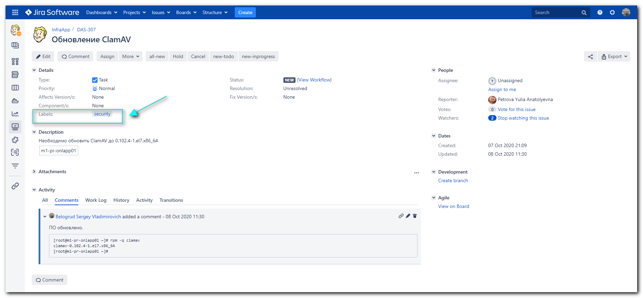

# Move the task to our space in Jira: “IN”.
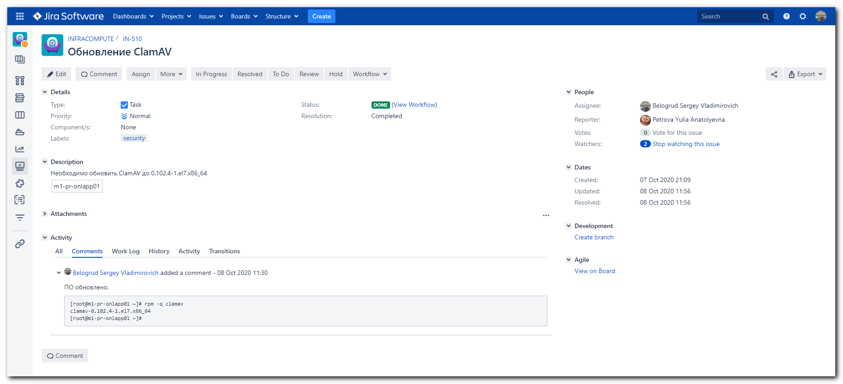

# And mark it as “Done” after it was completed. As usual for all regular tasks.

